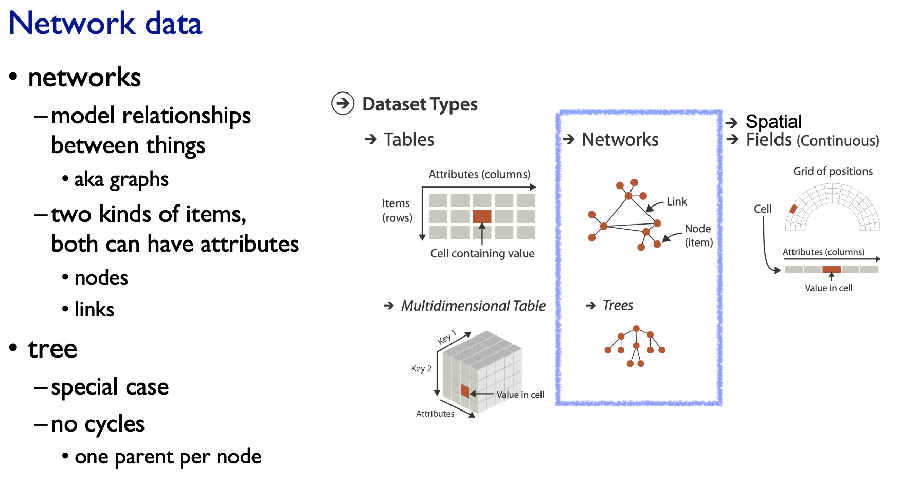

Nodes and Links are attributes separately.   
No cycles.  
Only one parent and shows hierarchical structure.

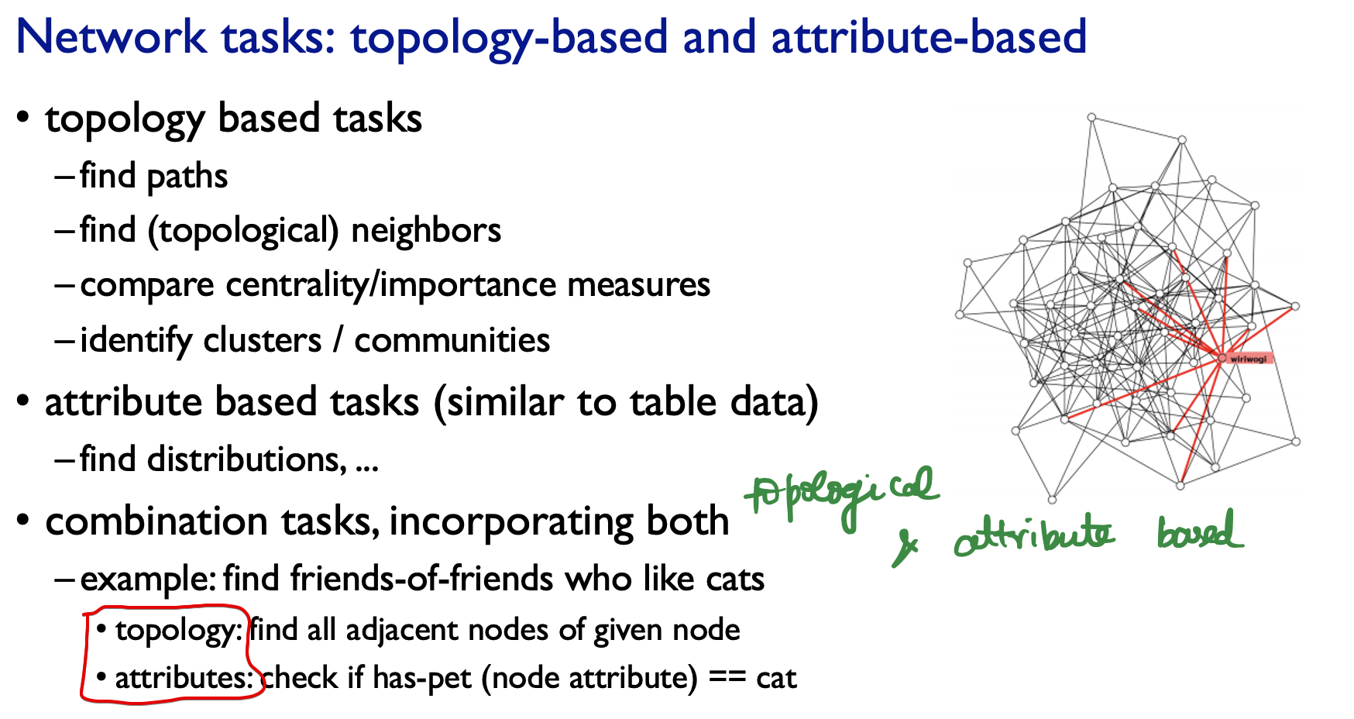

It is topology based task, in-addition to attribute based task.

Traversing from one node to other with the links

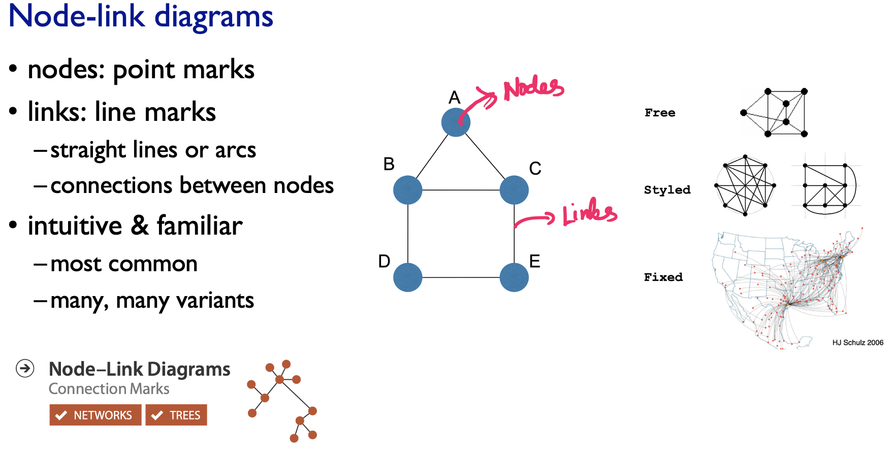

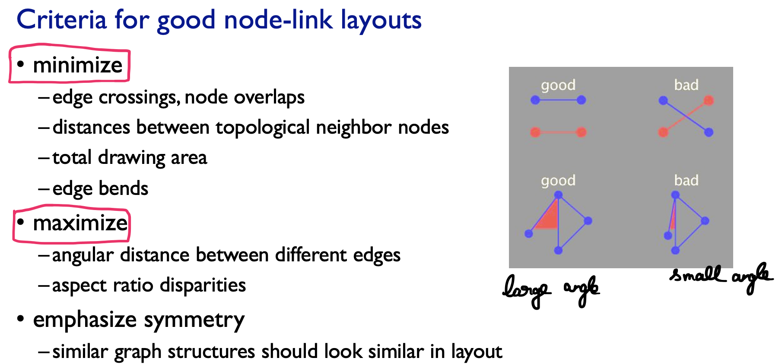

We have to minimize the overlapping of nodes on top of each-other.  
We have to avoid the small angles between the nodes

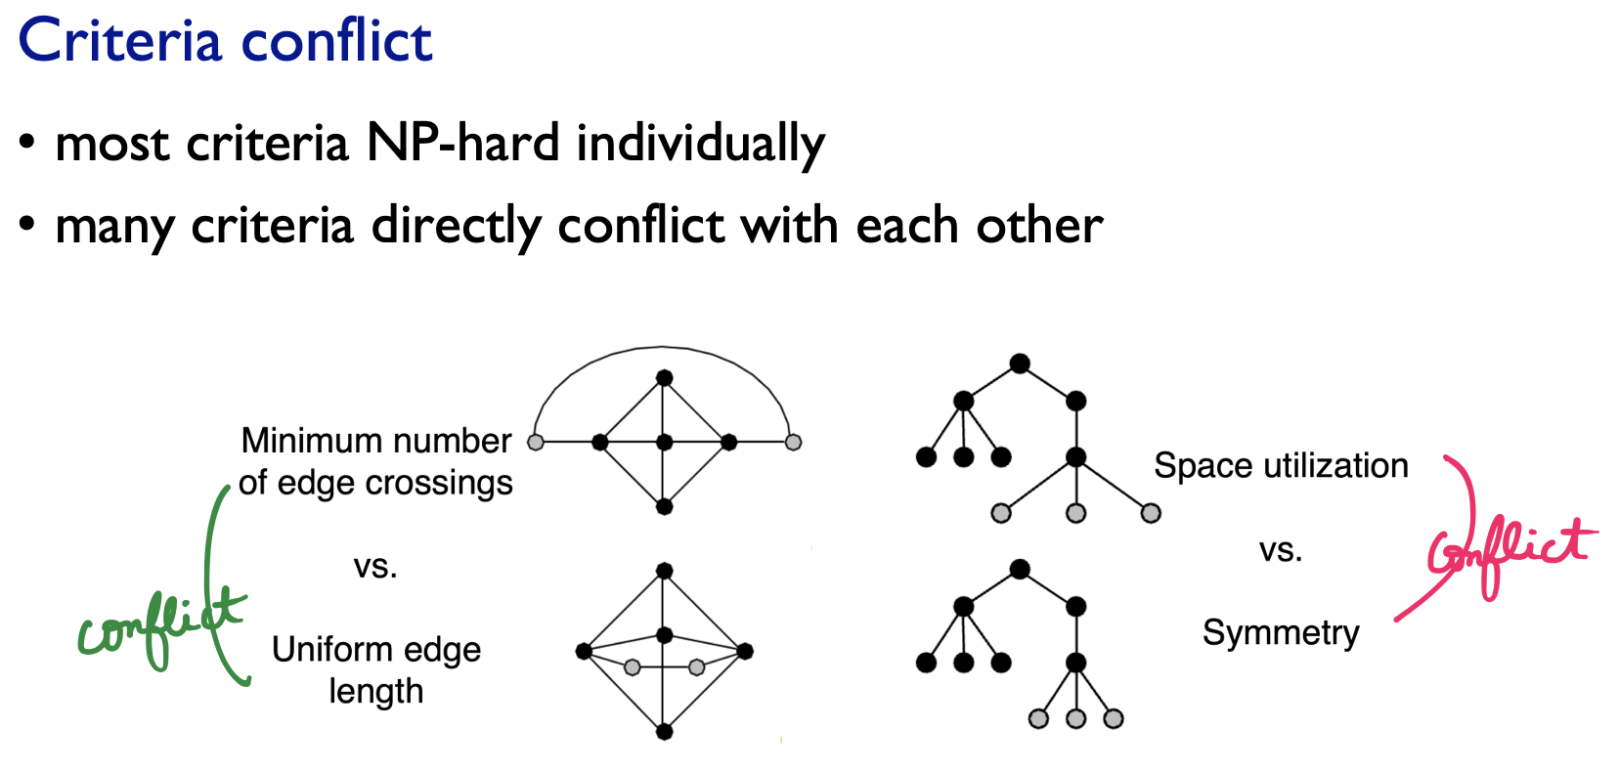

In network visualization we are typically trying to come up with some heuristics of what criteria makes sense in what contexts, because we know that we can’t just brute force optimize and get a known optimal solution once these graphs are getting larger than just a

tiny-tiny number of nodes.

# **Force-directed placement**

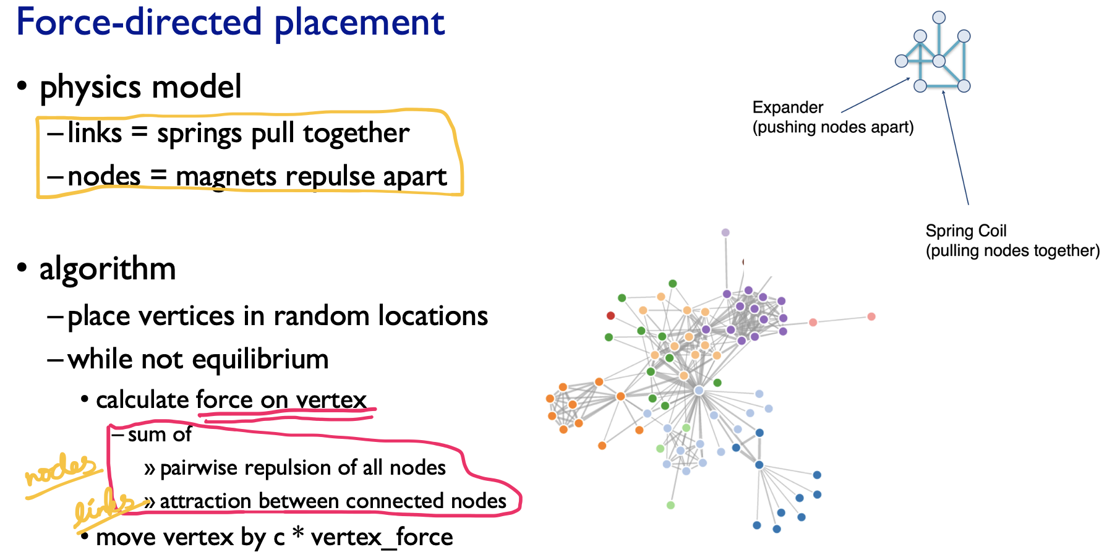

We can put all the vertices/nodes any-where.  
And then if you haven’t converged your algorithm, you calculate these combined forces.  
And you have all the nodes that tries to repul each-other

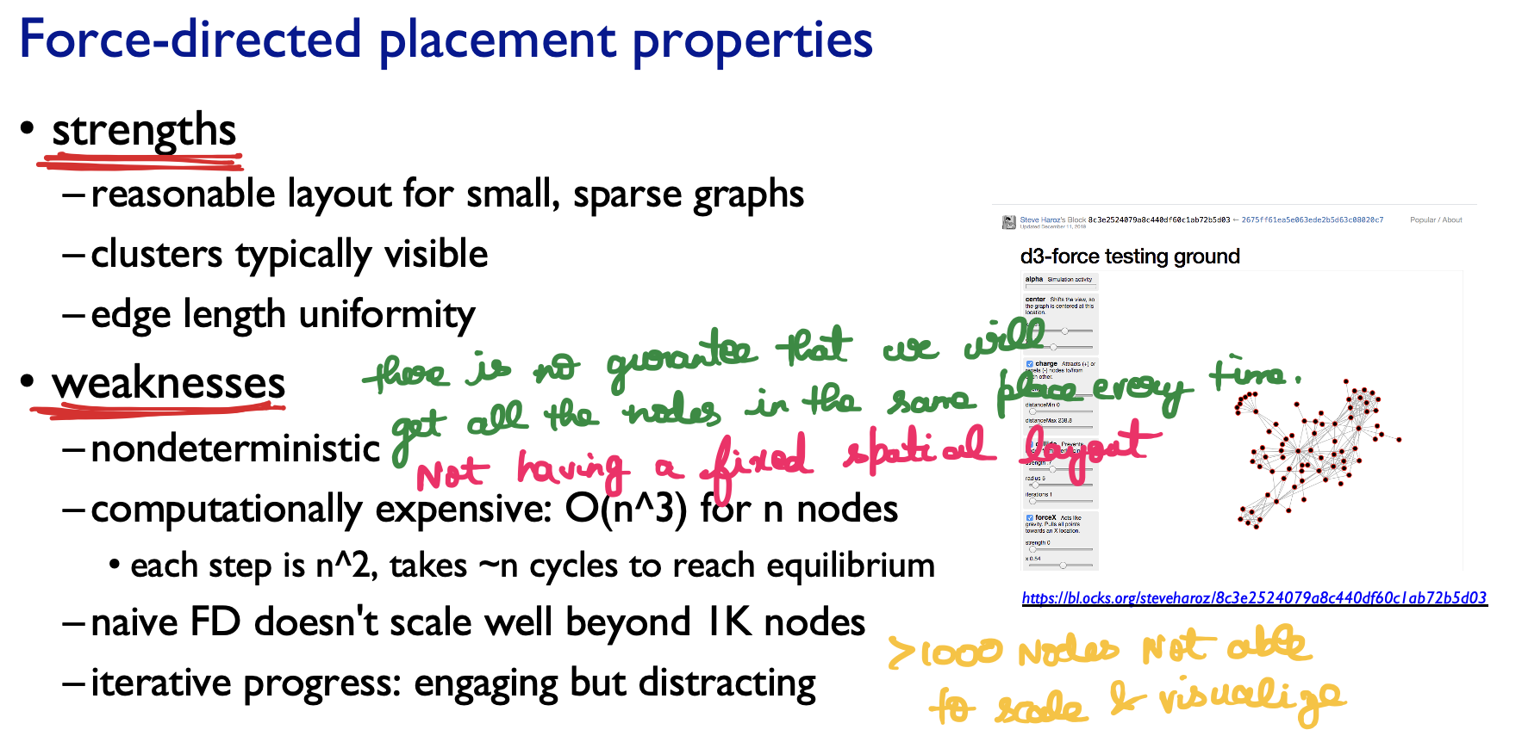

Spatial position 🡪 Algorithmically we are trying to minimize the number of crossings. And so the idiom result of that is not directly encoding a particular attribute with spatial position with pure force directed placement.

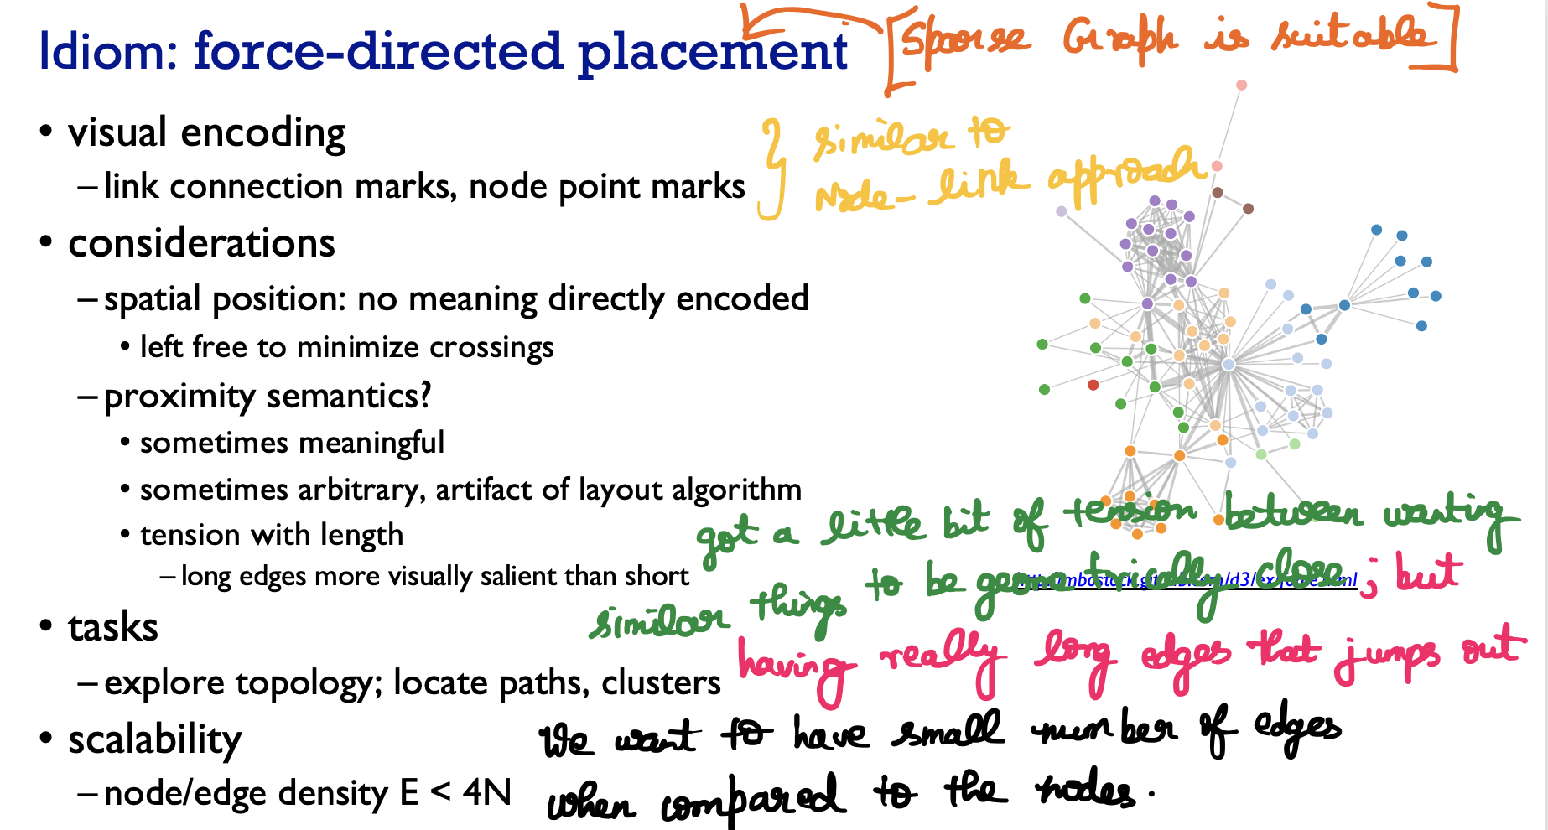

# **Circular Layout / Arc Diagrams**

Alternative for node-link diagrams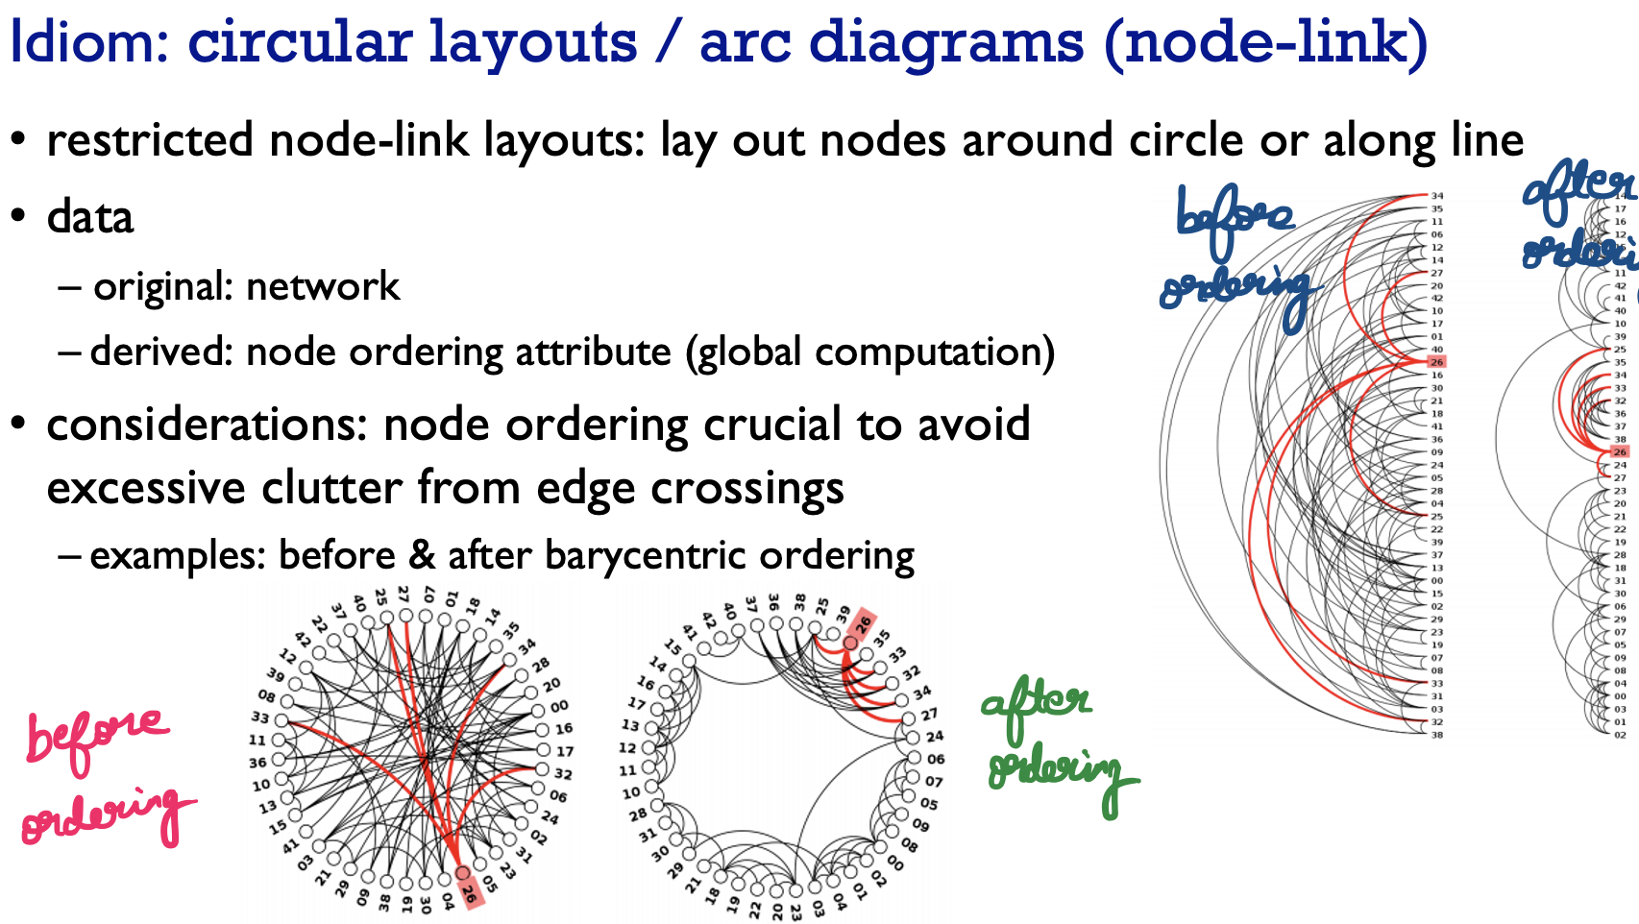

Circular Layout 🡪 Nodes are put all around the circles  
Arc diagrams 🡪 Nodes are laid along a line.

From an analysis point of view, we are taking out original network, and we are deriving a new attribute on the nodes.   
This deriving requires a global computation. And that node ordering is done.  
This is done to avoid excessive clutter from these edge crossings.

There are many approaches to node ordering 🡪 barycentric ordering

# **Adjacency Matrix**

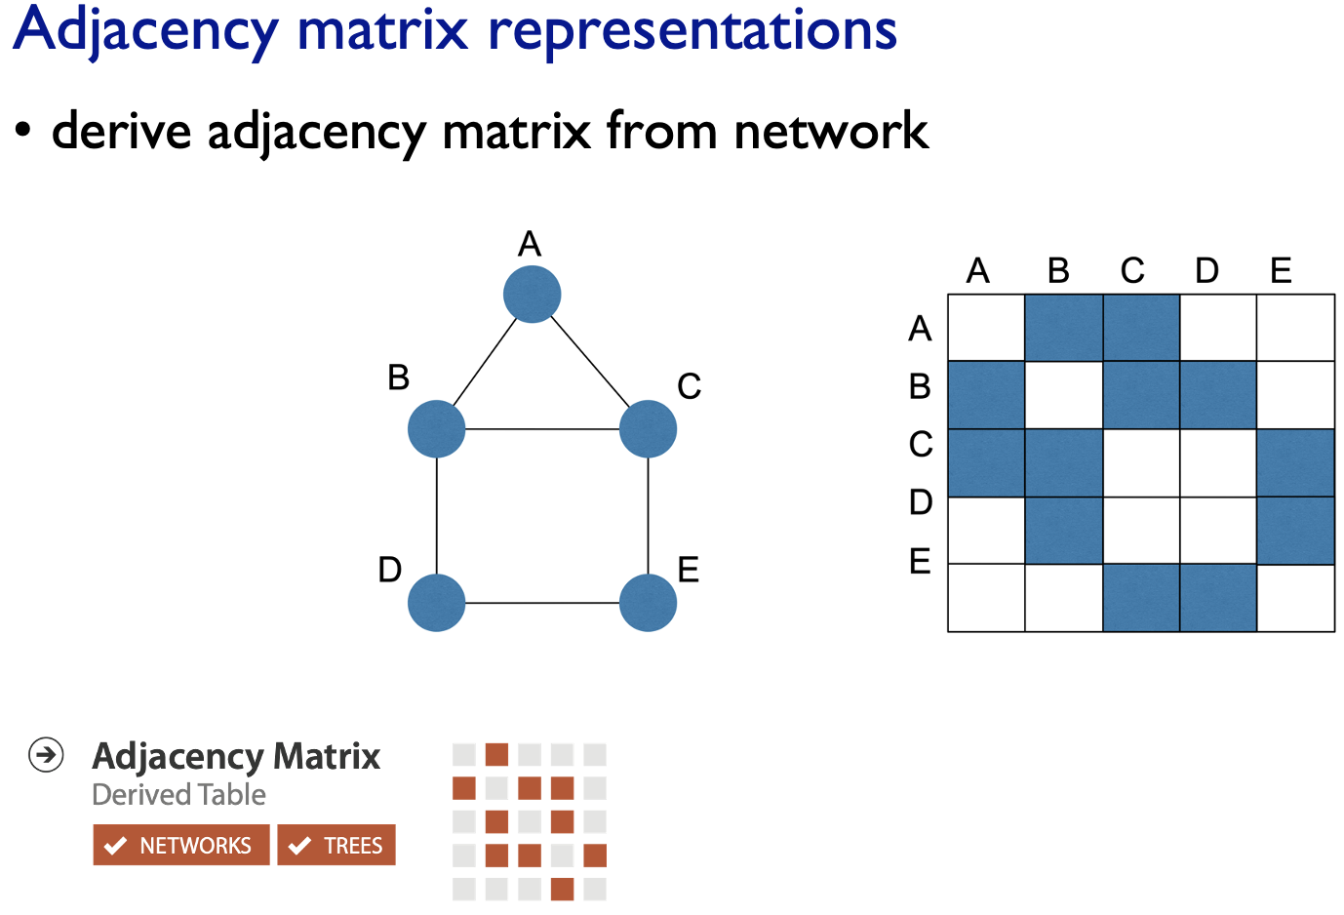

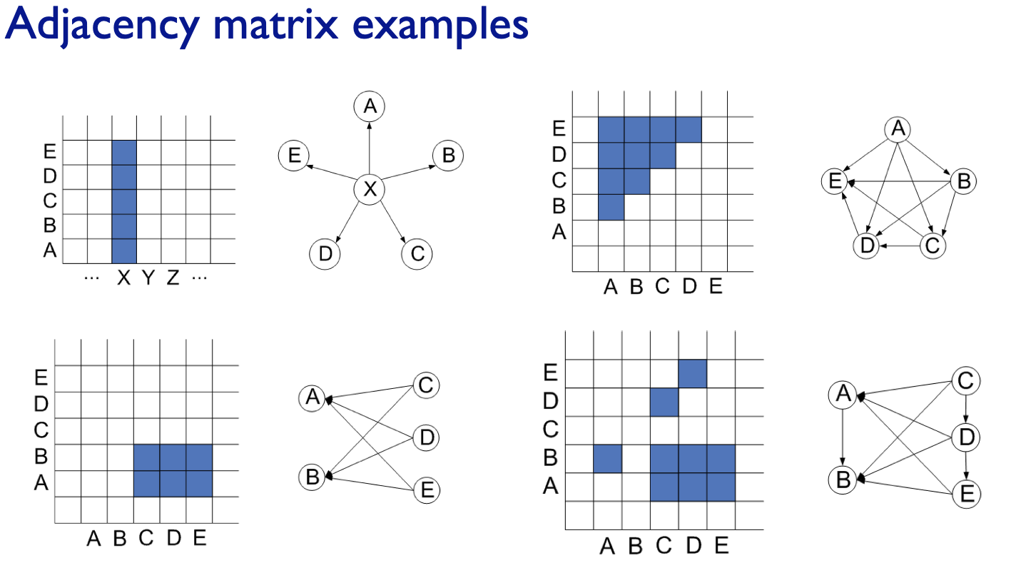

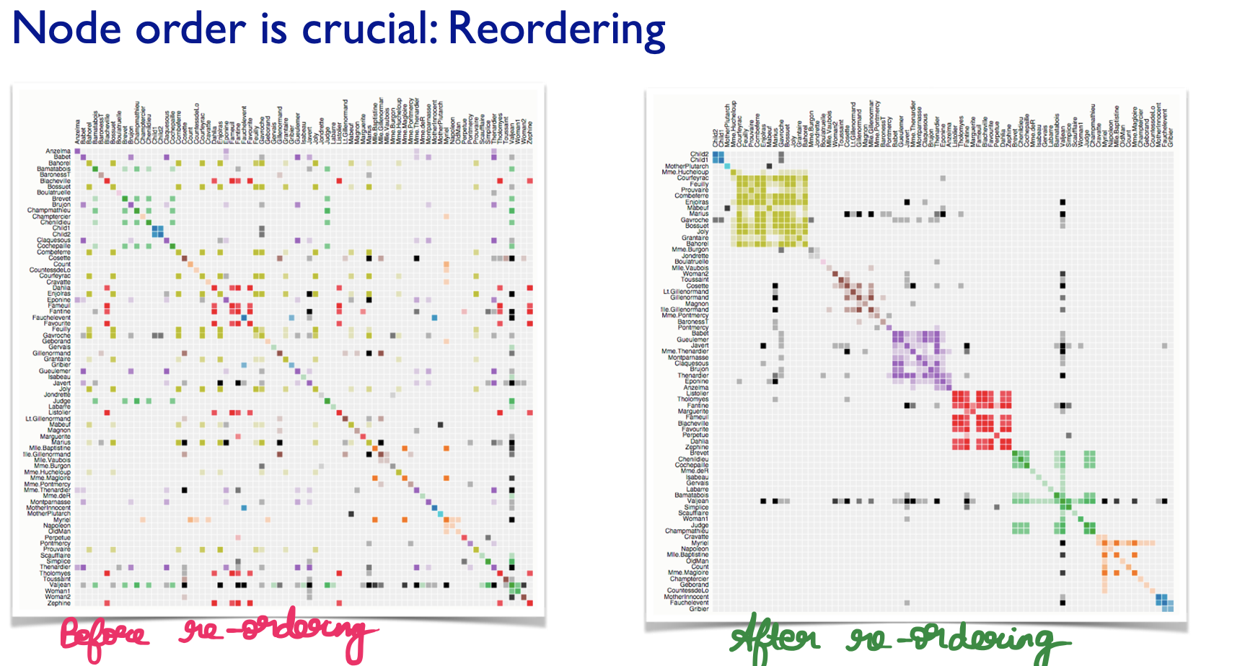

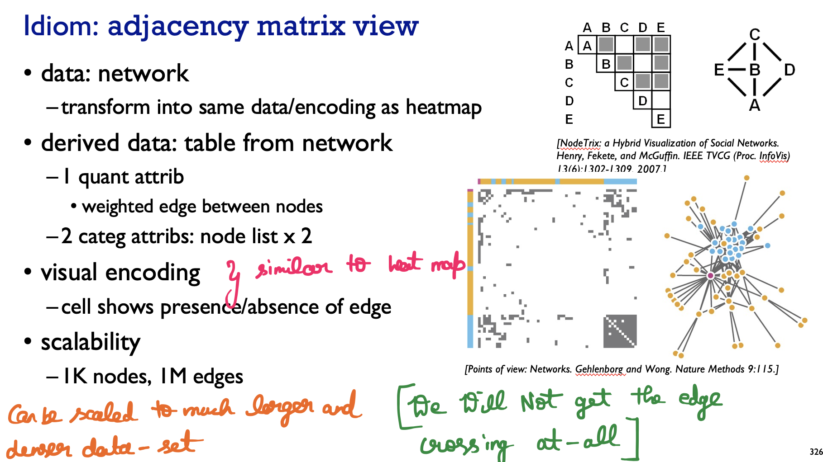

Taking a network data and transforming (i.e) creating a table

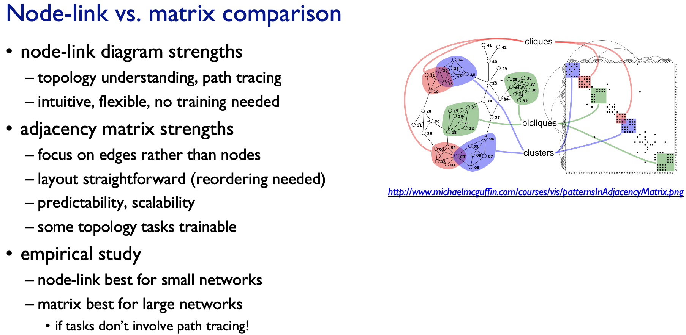

Node-Link 🡪 They are flexible, easy to understand the topology, tracing paths. People don’t need any training to interpret them.

Adjacency matrix 🡪 It is an edge centric view rather than node centric view.

Conclusion:  
If we get smaller networks, node link diagram 🡪 better

If we get larger networks, and don’t want to path trace Adjacency matrix 🡪 better

Above all are networks

# **Trees**

## **Radial Node Link Tree**

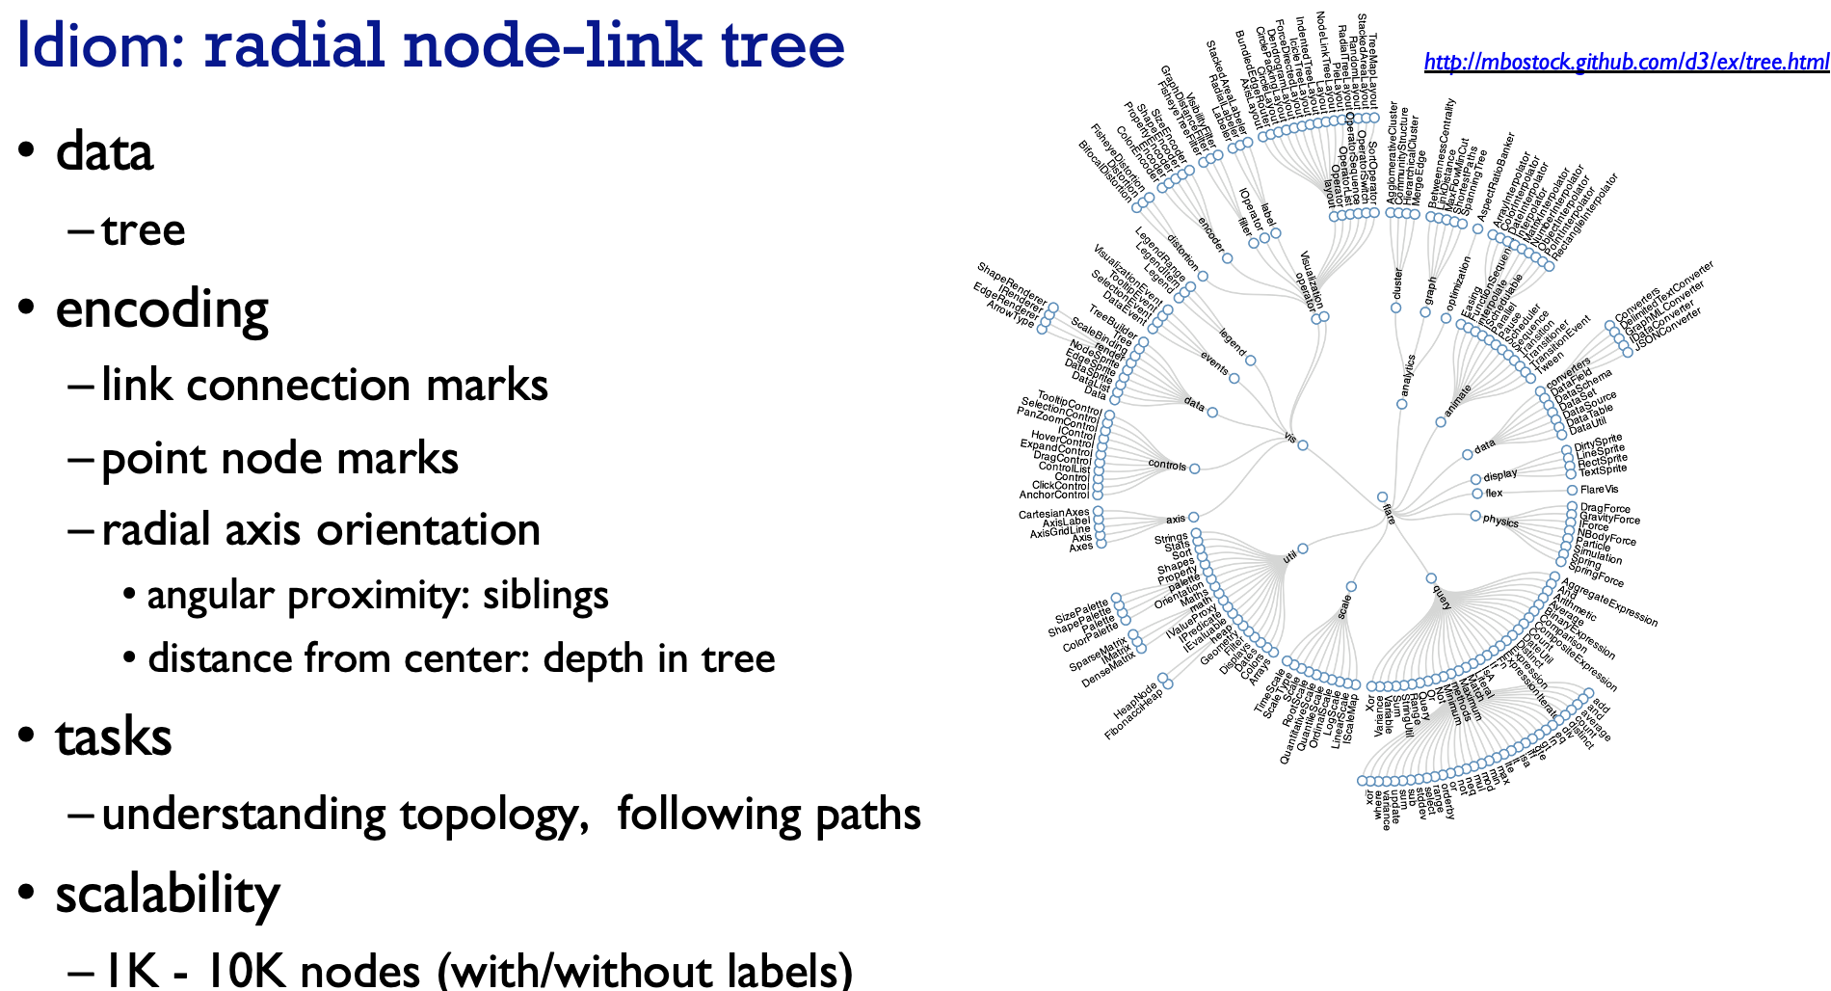

From an angular point of view, the angular things which are closer to each-other are siblings (i.e children of same parents).

Understand the Depth of a tree based on the radial distance from that center node.

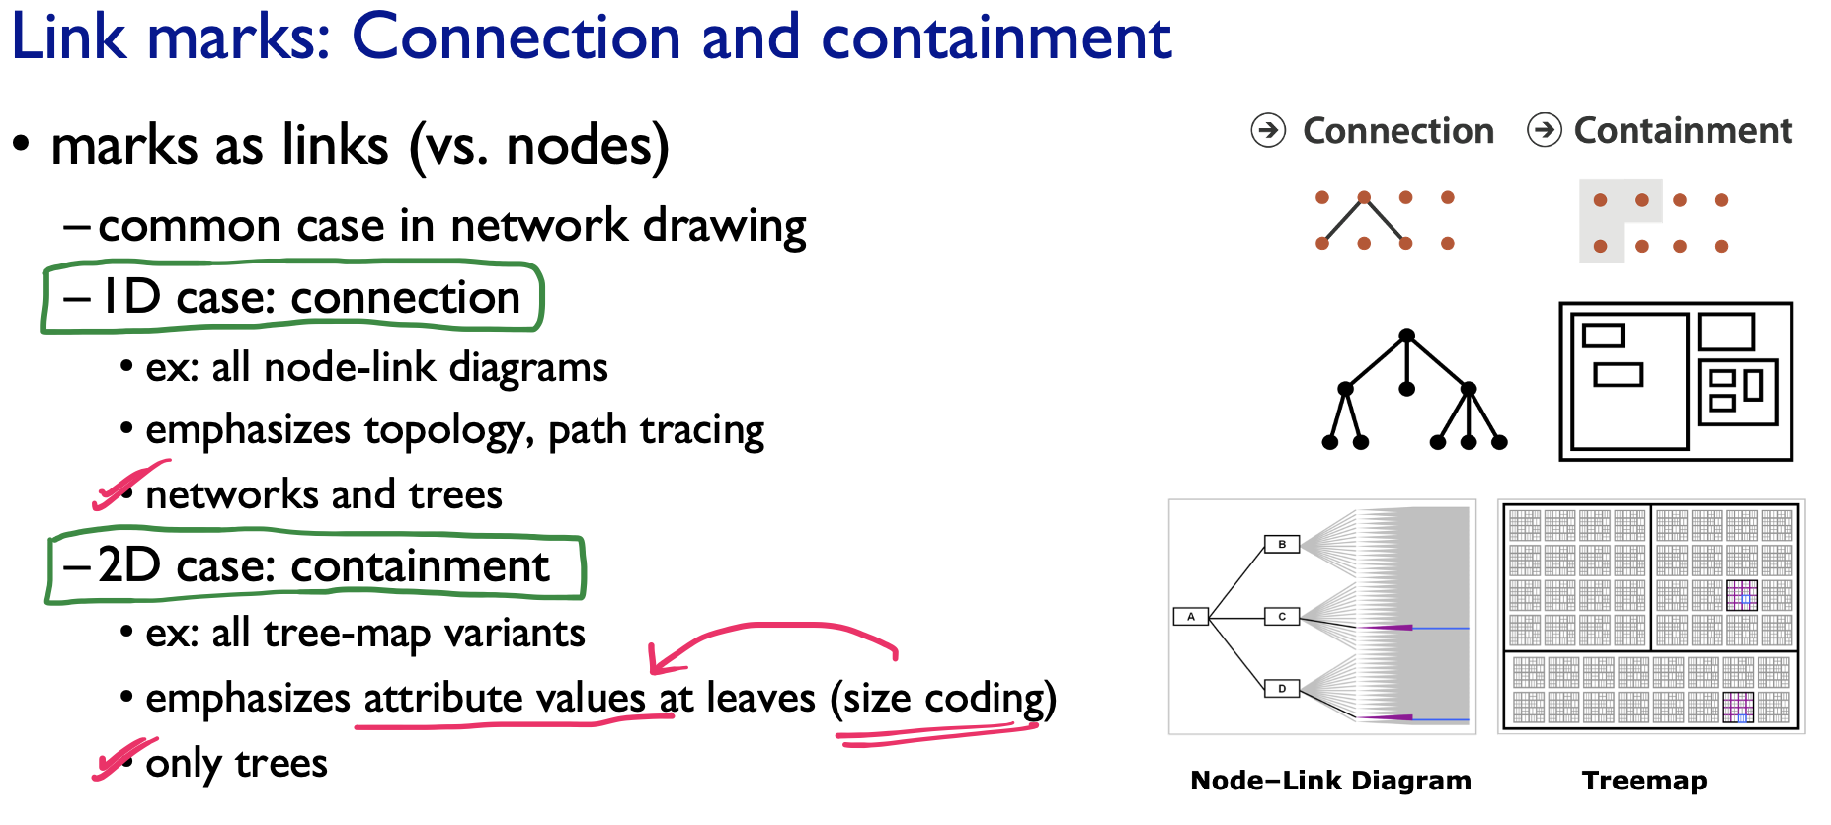

## **Tree Map**

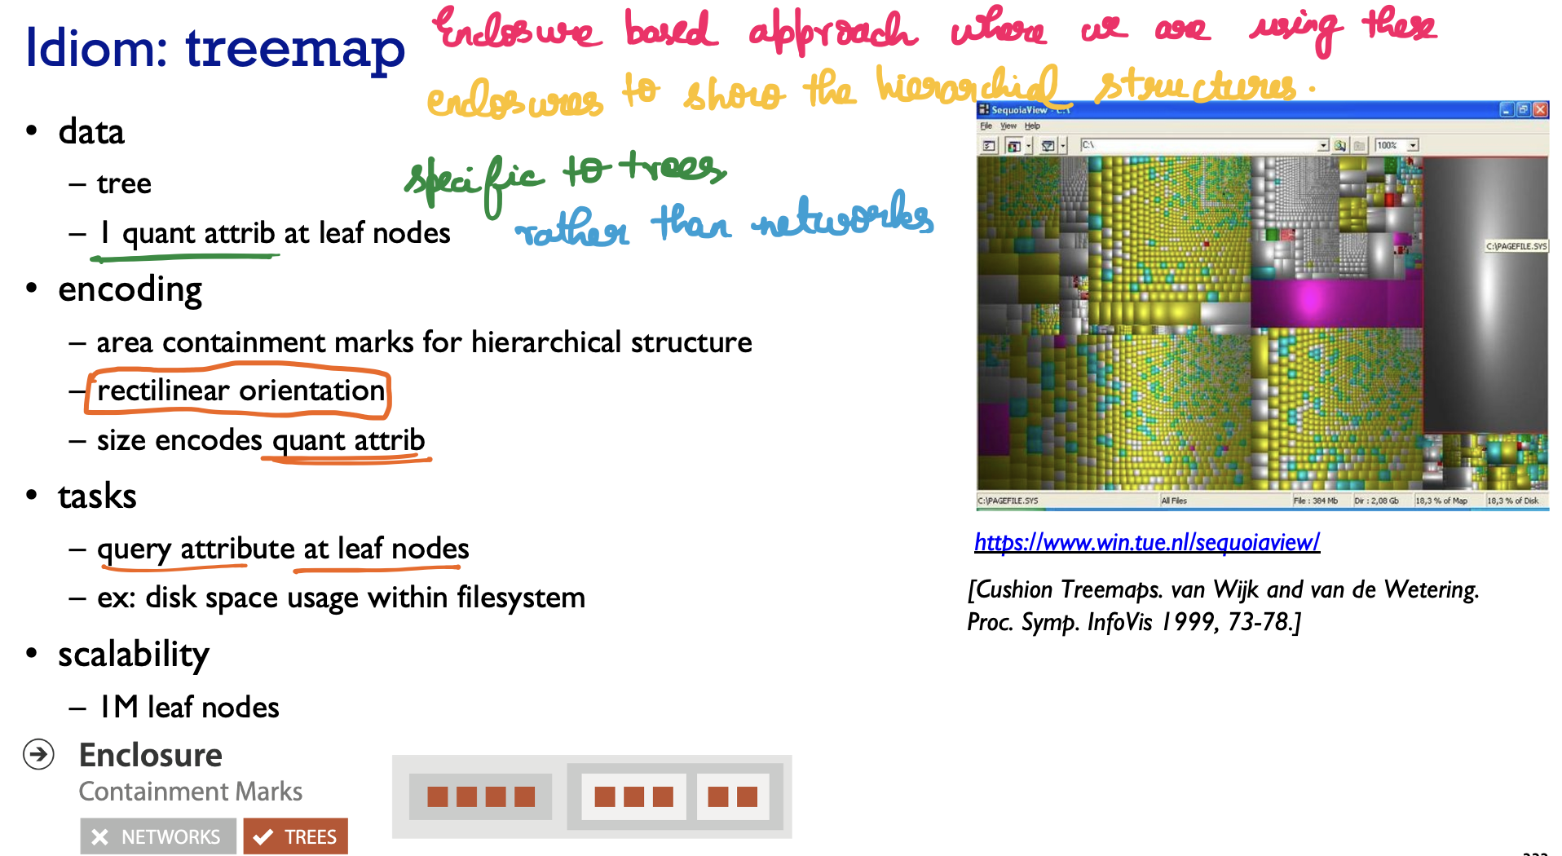

Typically all the parents takes most space when compared to children.

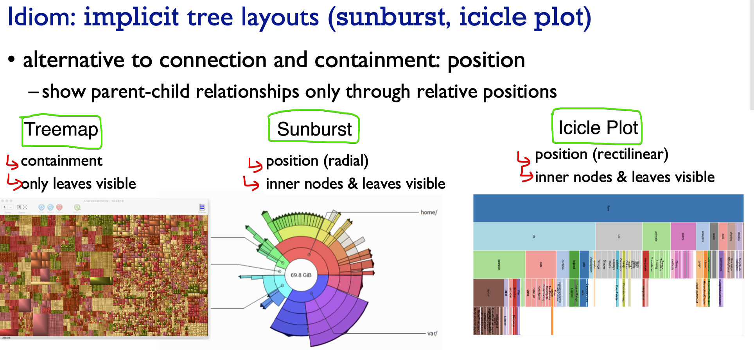

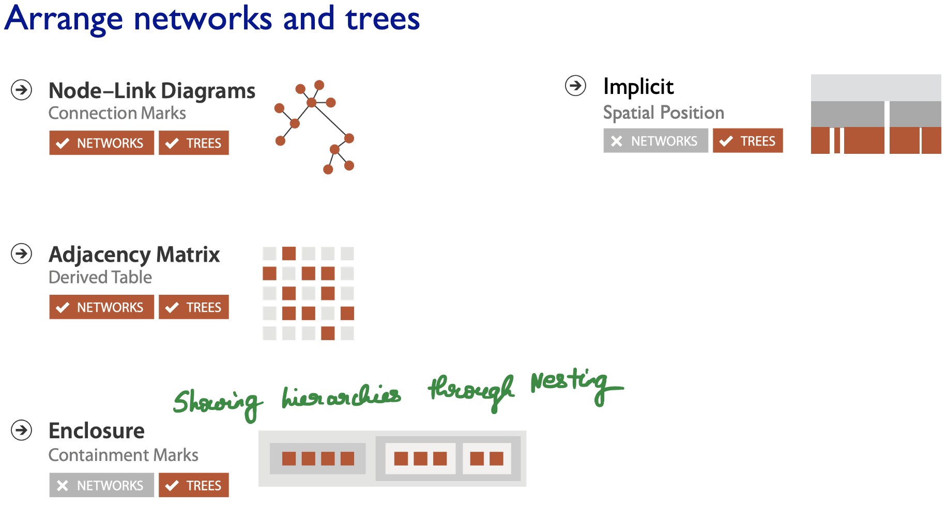

# **Node Link Diagrams**

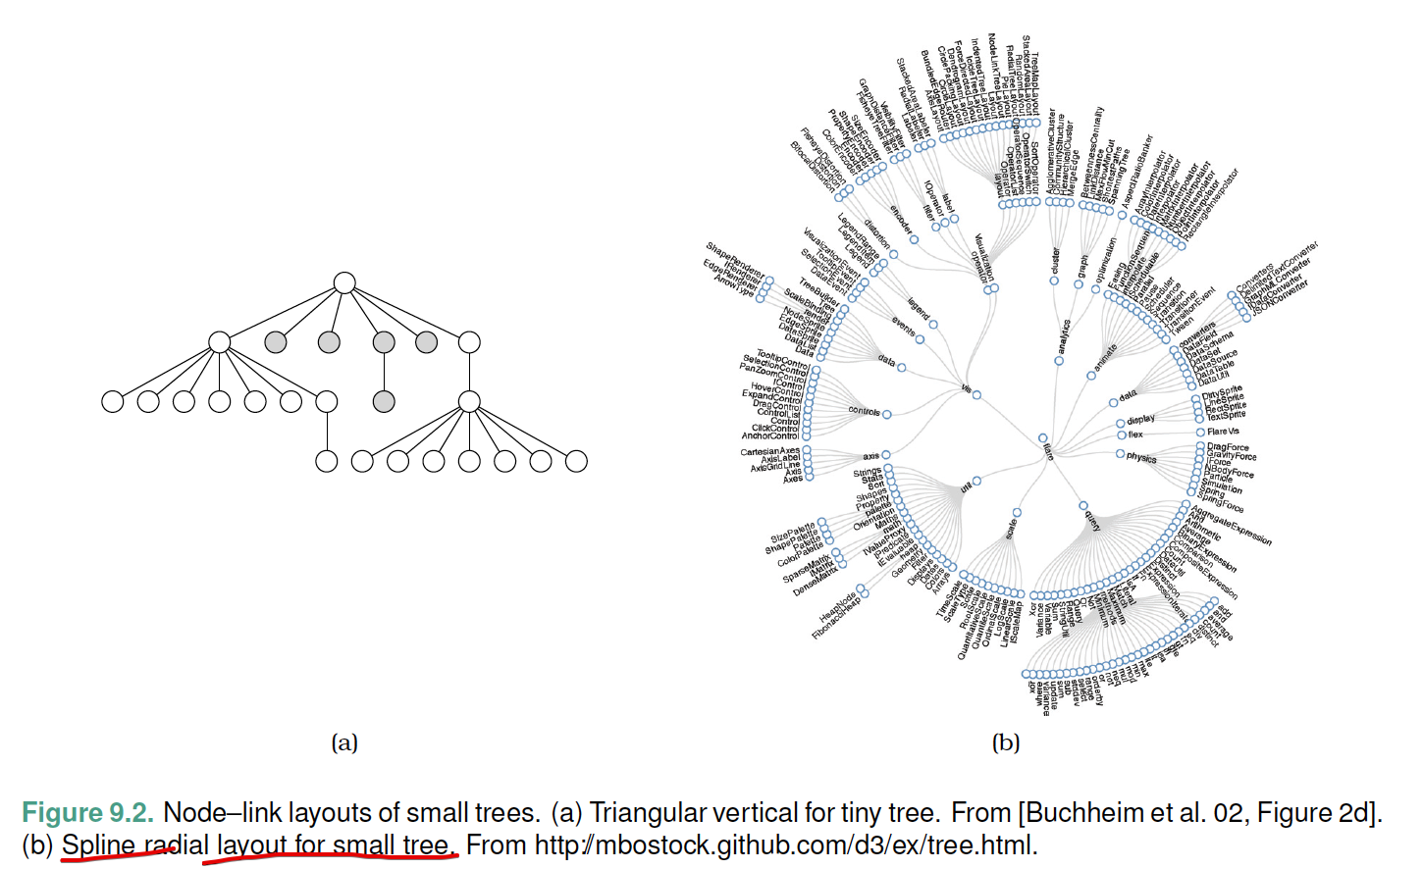

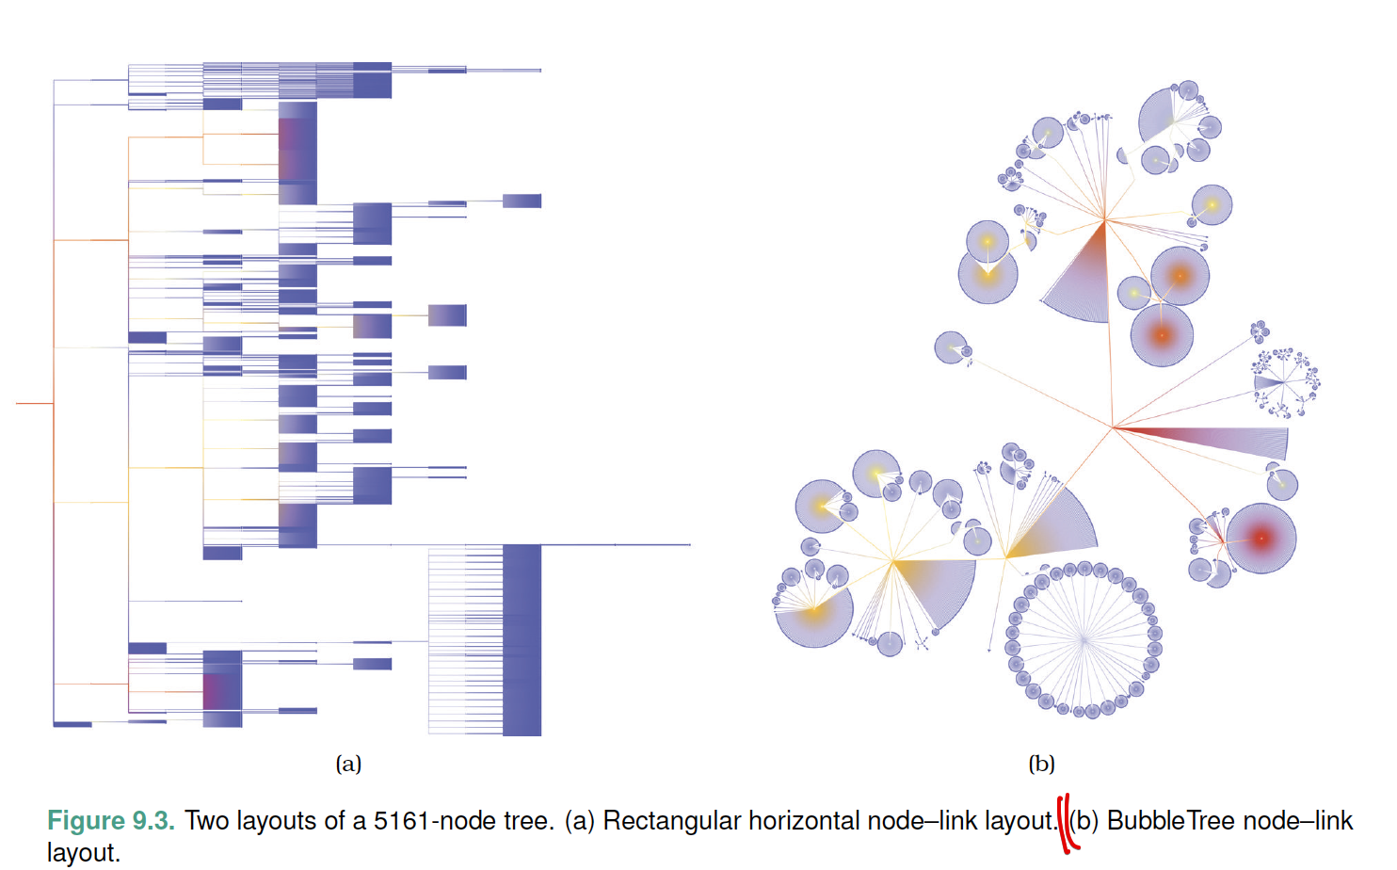

## **Eg: Force Directed Placement**

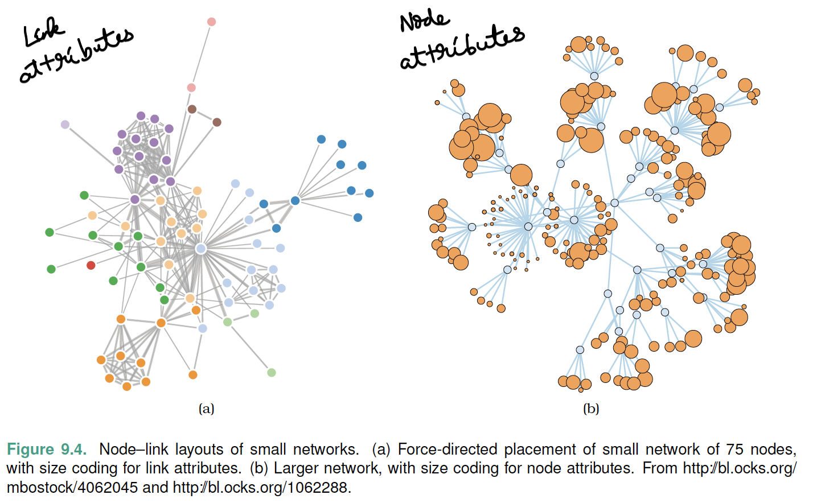

## **Eg: sfdp**

Number of Nodes increase, links increase leads to  
Node link diagram de-generates into hair-fall diagram

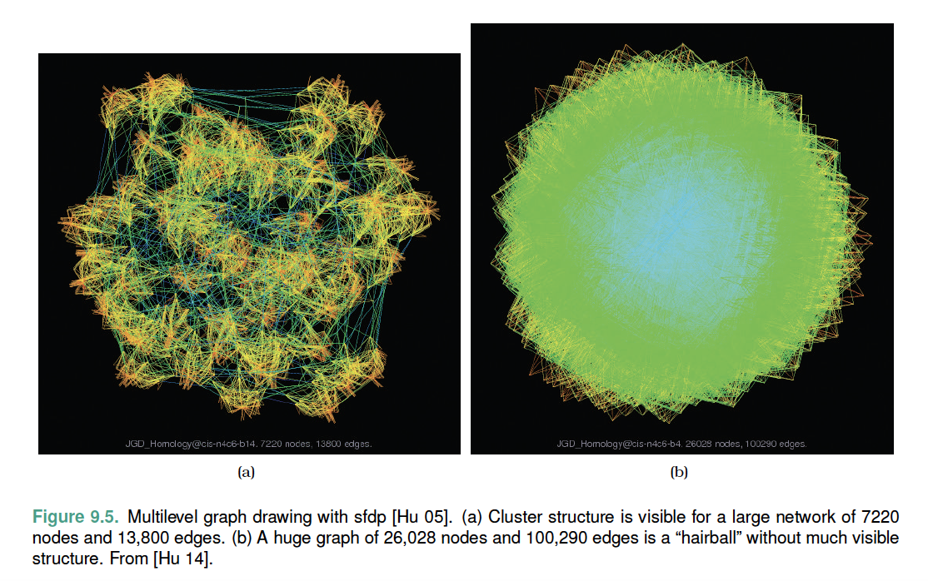

# **Visual Encoding for tree data**

## **Rectilinear vertical node–link**

## **Icicle**

## **Radial node–link**

## **Concentric-circles**

## **Nested Circle Tree map**

## **Indented Outline**

# **Hierarchical Structures**

## **Space Filling**

### **Rectangular Layout**

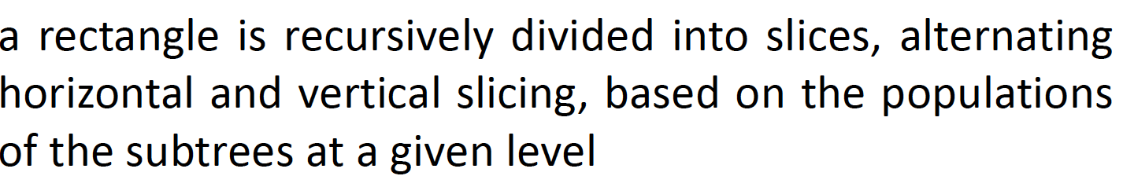

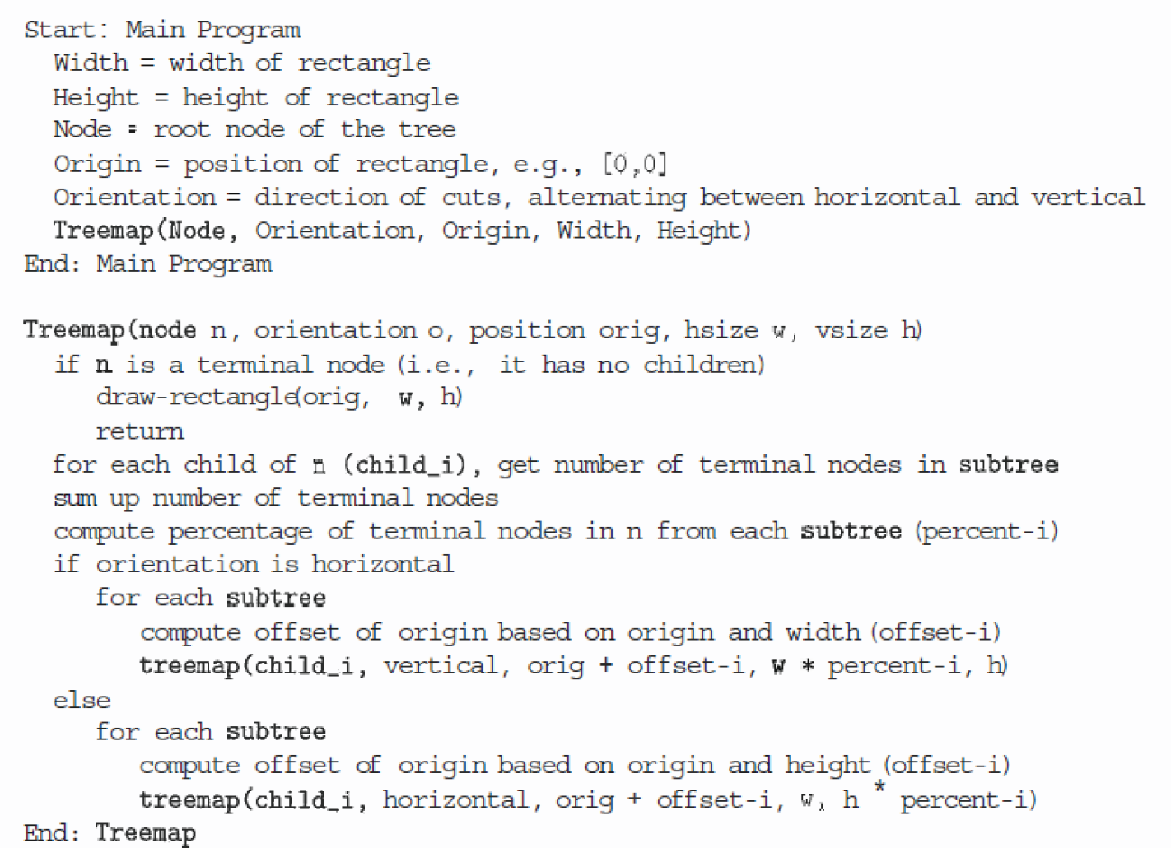

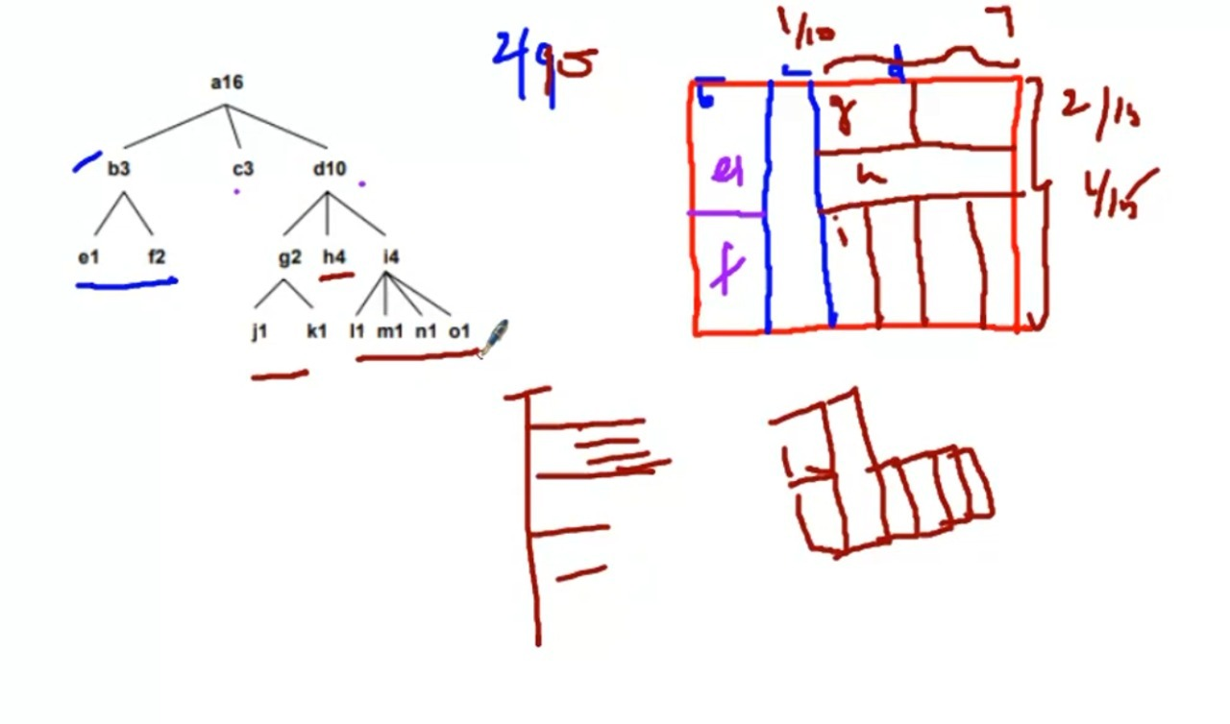

### **Radial Layout**

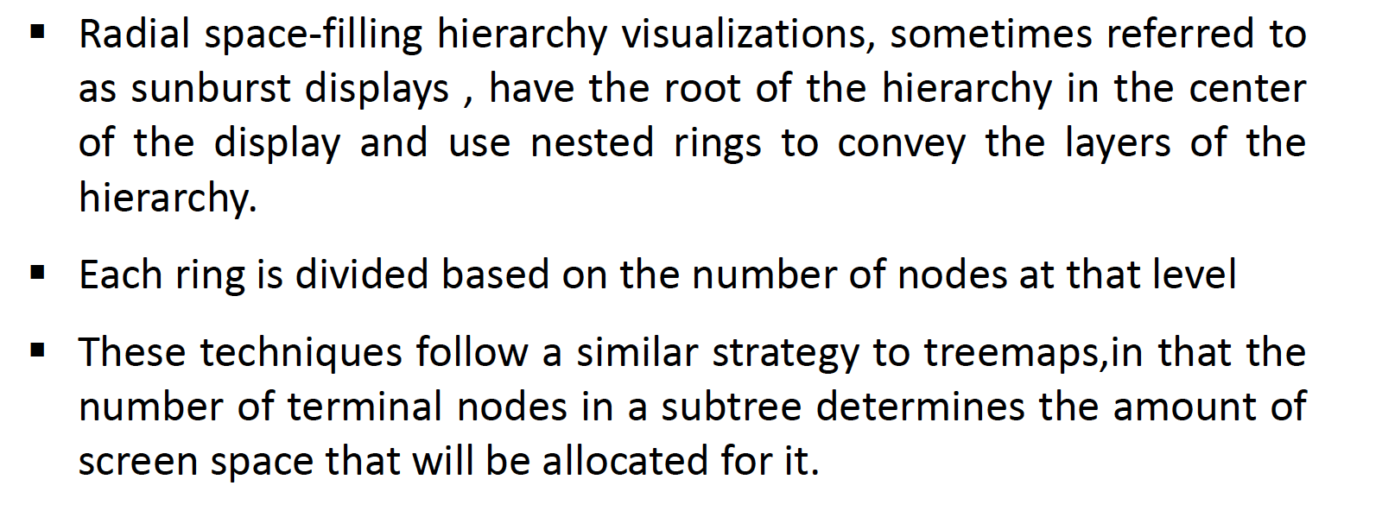  
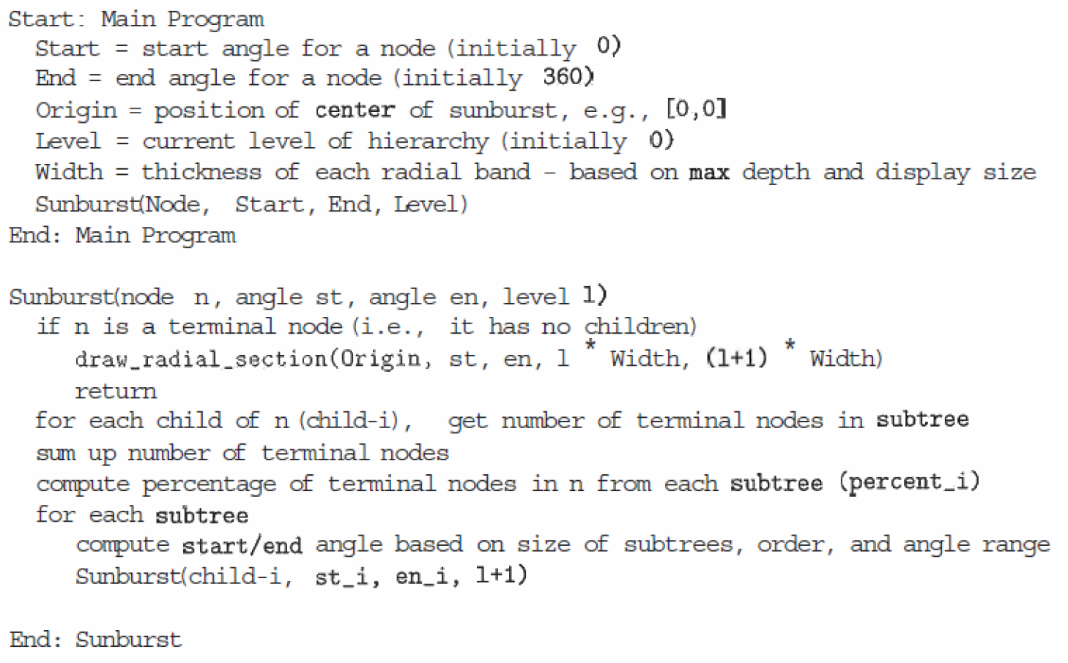

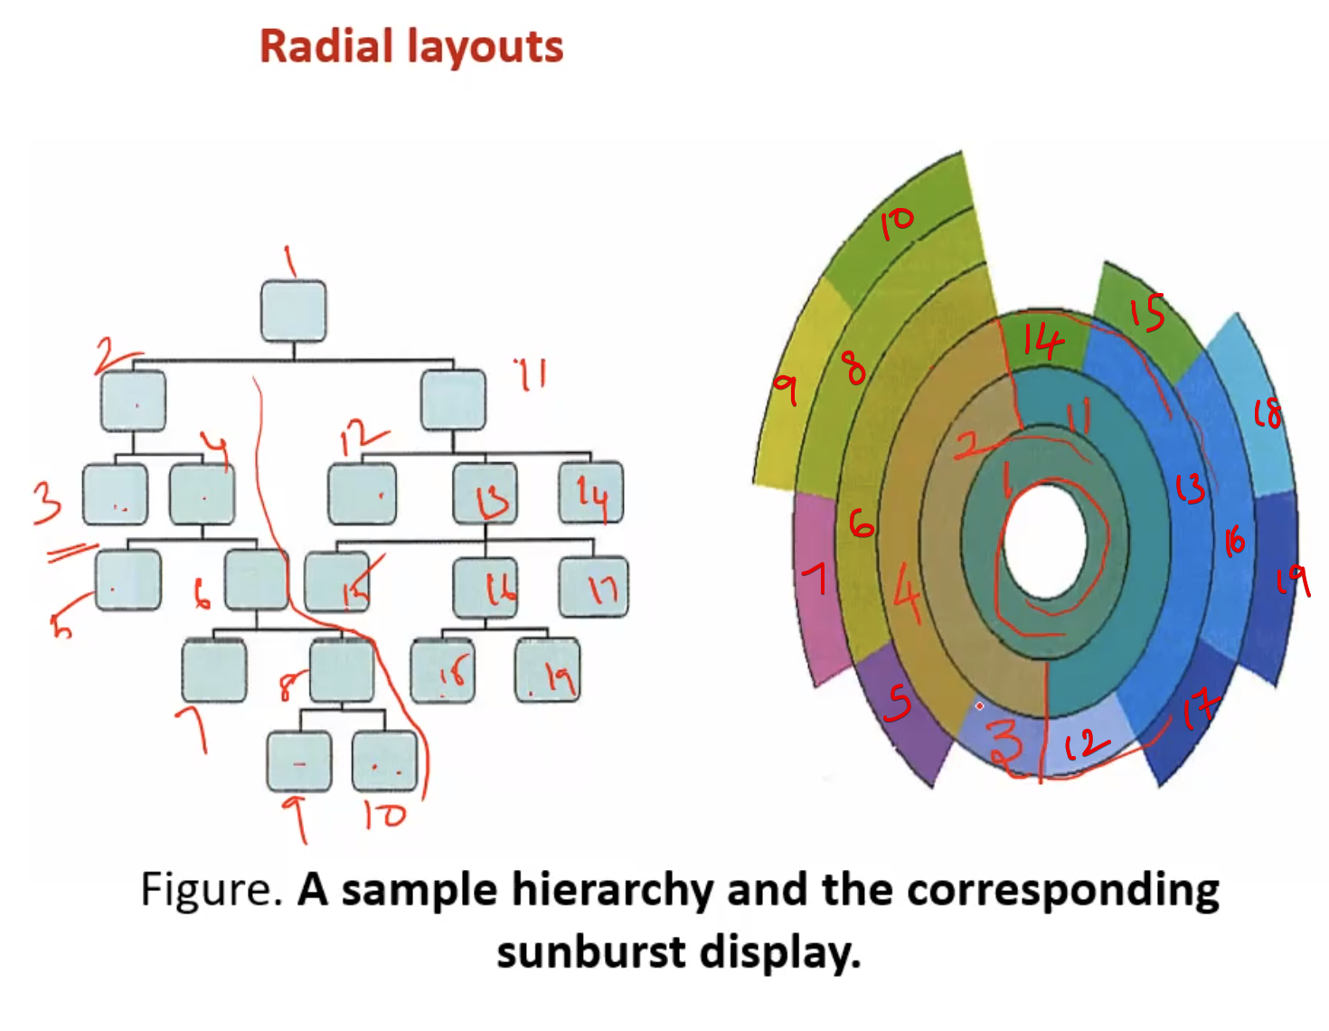

## **Non Space Filling**

